**Encapsulation in Java:**

Encapsulation in Java is a process of wrapping code and data together into a single unit, for example, a capsule which is mixed of several medicines.

We can create a fully encapsulated class in Java by making all the data members of the class private. Now we can use setter and getter methods to set and get the data in it.

Advantage of Encapsulation in Java:

It provides you the control over the data. Suppose you want to set the value of id which should be greater than 100 only, you can write the logic inside the setter method. You can write the logic not to store the negative numbers in the setter methods.

It is a way to achieve data hiding in Java because other class will not be able to access the data through the private data members.

**Simple Example of Encapsulation in Java:**

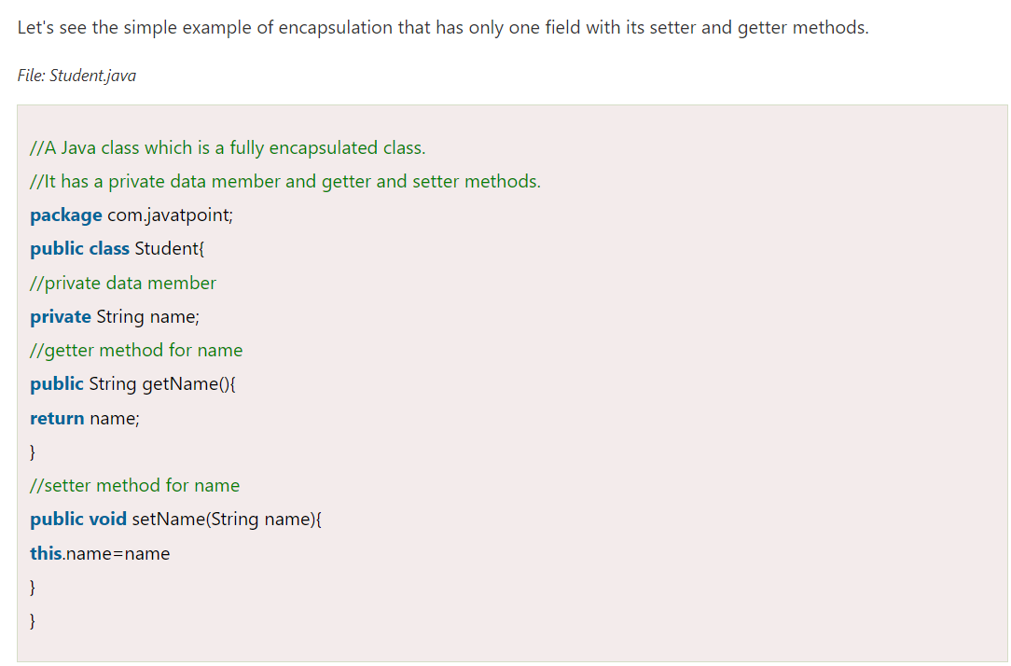

**Read-Only class:**

**Write-Only class:**

**Another Example of Encapsulation in Java:**



